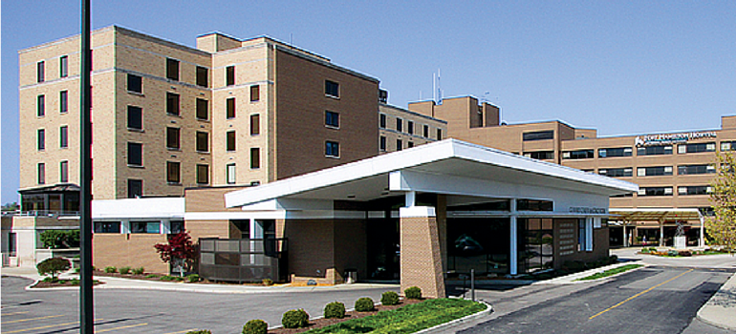
Fort Hamilton

F.O.R.T.
Fort’s Opiate Recovery Taskforce
Our Community Partners:

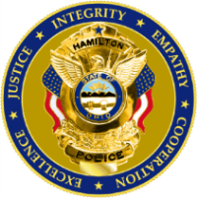
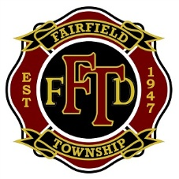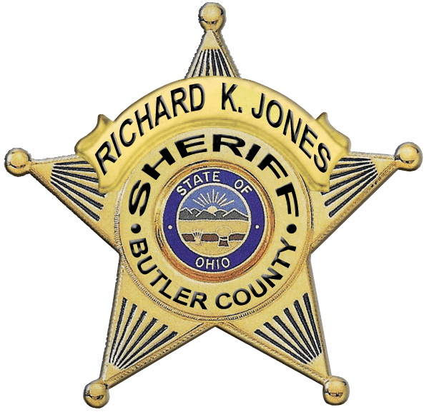
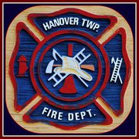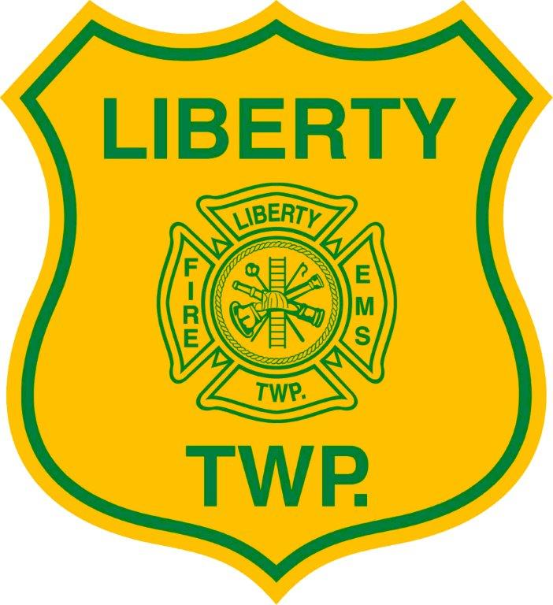
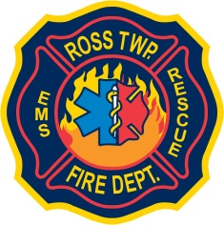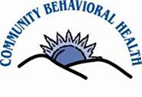
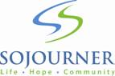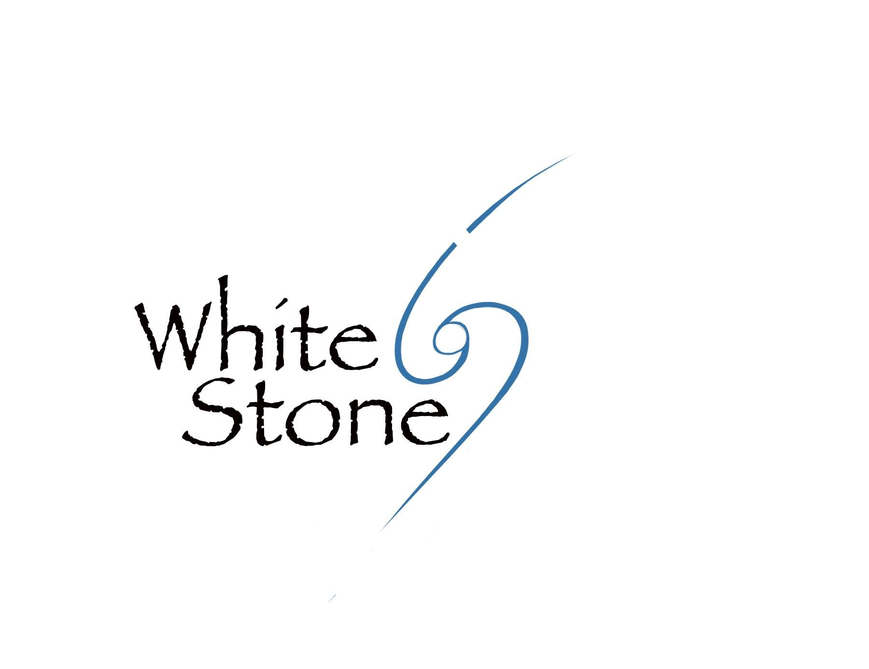

Recovery Resource Packet

Our Mission:
To provide resources for available services in our community to patients and/or their families who are addicted or their loved one is addicted to opiates and to address the stigma surrounding drug use and people who use drugs.

HOTLINES
Addiction Services Council | 513-281-7880 | www.addictionservicescouncil.org
Butler County Crisis Hotline | 1-844-4CRISIS  1-844-427-4747 | www.nami-bc.org
Substance Abuse Mental Health Service Administration (SAMHSA) | 1-800-662-HELP | www.Findtreatment.samhsa.gov
Narcotics Anonymous | 513-820-2947 | www.nacincinnati.com

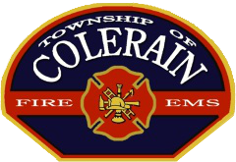
Our special thanks to Colerain Township’s Program and for helping us
get our program off the ground.
Thank you Dan Meloy and Will Mueller
Resources
Agency | Contact Info | Services
Access Counseling Services | 4464 S. Dixie Highway, Middletown  (513)-649-8008  www.acscounseling.com | Training  Individual Counseling  Referral and Information  Assessment  Outreach  Crisis Intervention  Medical/Somatic  Consultation  Urinalysis: Lab Analysis  Intensive Outpatient  Group Counseling  Case Management
Beckett Springs Psychiatric Hospital | 8614 Shepherd Farm Drive  West Chester, Ohio 45069  (513)-942-9500  www.beckettsprings.com | Provider offers heroin detox and inpatient and outpatient treatment. MEDICARE AND PRIVATE INSURANCE ONLY
Butler Behavioral Health Services | 210 S. Second Street  Hamilton, Ohio 45011  (513)-881-7189 | Group Counseling  Referral and Information  Urinalysis: Lab Analysis  Family Counseling  Individual Counseling  Crisis Intervention  Assessment  Case Management  Consultation
Butler County Mental Health and Addiction Recovery Services Board | (513)-860-9240  5963 Boymel Rd.  Fairfield, Ohio 45014 | Diagnostic assessment  Counseling (individual & group)  Medication  Crisis intervention  Education  Consultation & prevention  Vocational & employment  Housing & residential  Forensic evaluation  Community psychiatric supportive treatment services
Community Behavioral Health | 820 S. MLK Jr. Blvd., Hamilton  (513)-887-8500  or  1659 S. Breiel Boulevard, Middletown  (513)-424-0921 ext. 10  www.cbh-services.org | Provider offers outpatient counseling services.  Diagnostic Assessment (Non-physician)  Group Counseling  Individual Counseling  Case Management  Individual Community Support  Urinalysis: Lab Analysis  Crisis Intervention  Diagnostic Assessment (Physician)  Assessment  Medication Somatic  Medical/Somatic  Crisis Intervention
Community Recovery Project | communityrecoveryproject.org | Community Recovery Project exists to provide access to education and resources on the subject of Opiate and Heroin addiction.
F.O.R.T.  Fort’s Opiate Recovery Taskforce | Jennifer Mason - Trauma and EMS Outreach Coordinator (513)-867-2116  Tari Huffman - Manager of Safety (513)-867-3339  Larry Davis – Chaplain (513)-867-2000 | Targeted assistance for patients at Fort Hamilton Hospital
Hamilton Narcotics Anonymous | www.hamascna.org
Modern Psychiatry and Wellness | West Chester Location  6942 Tylersville Rd  West Chester, OH 45069  Phone: (513)-868-0055  Fax: (513)-297-7577  www.modernpsych.com  Hamilton Location  25 North F Street  Hamilton, OH 45013  Phone: ( 513)-795-7557  Fax: 513-795-7518 | Provider offers medication assisted outpatient treatment
Nar-Anon Family Groups  Naranoncentral.org | (888)-425-2666  Hamilton:Trinity Episcopal Church 115 N 6th St. Hamilton at 7pm. Contact person: Laury V  (513)-910-8349  Fairfield:Rolling Hills Baptist Church 5742 Pleasant Ave Fairfield at 7:30 Contacts: Susan S (513)-403-6768 or Keith S (513)-518-4244 | Family Groups
The Next Right Thing | 930 Ninth Avenue, Middletown  (513)-727-1438 | Provider offers outpatient counseling services
SAFE Substance Abuse Family Education Groups | Mondays from 6 to 8pm  Zion Lutheran Church on Front Street in Hamilton  Questions? Call Stephanie at:  (513)-868-5125 or  Wednesdays 5:30p.m. to 7:30p.m.  Breiel Boulevard Church of God  2000 Breiel Boulevard, Middletown | Education
Sojourner Recovery Services | 515 Dayton Street, Hamilton  (513)-868-7654  www.sojournerrecovery.org | Provider offers residential and outpatient counseling services  Ambulatory Detox
Transitional Living Inc | 2052 Princeton Road  Hamilton, Ohio 45011  (513)-863-6383  1131 Manchester Ave. – 2nd Floor  Middletown, Ohio 45042  (513) 422-4004 | Substance Abuse Treatment  Mental Health Services
White Stone Psychiatric and Addiction Services | 5108 Sandy Lane  Fairfield, OH 45014  Phone: (513) 234-5959  www.whitestonehope.com | Outpatient Addiction Services  Intensive Programming for Substance Use Disorders  Medication Assisted Treatment of Dependency and Withdrawal  Addiction Treatment for Pregnant Women  Reward and Reinforcement Strategies  Outpatient Mental Health Services  Mental Health Treatment for Pregnant Women  Psychotherapy  Medication Management  Urine Drug Screens  Consultations

Types of Treatment Available

Heroin and Opioid Addiction
- Taking the substance in larger amounts or for longer than you meant to
- Wanting to cut down or stop using the substance but not managing to
- Spending a lot of time getting, using, or recovering from use of the substance
- Cravings and urges to use the substance
- Not managing to do what you should at work, home or school, because of substance use
- Continuing to use, even when it causes problems in relationships
- Giving up important social, occupational or recreational activities because of substance use
- Using substances again and again, even when it puts you in danger
- Continuing to use, even when you know you have a physical or psychological problem that could have been caused or made worse by the substance
- Needing more of the substance to get the effect you want (tolerance)
- Development of withdrawal symptoms, which can be relieved by taking more of the substance.

Help for the Family
An addiction destroys families as much as it destroys individuals. Living with an addict is both heartbreaking and exhausting. Family members are torn between how to help the addict and how to avoid being sucked into the addict’s world.
Things You Can Do For the Addict
- Educate yourself on addiction and recovery.
- Try not to accuse or judge. Avoid name calling. This is a difficult time for both of you.
- Provide a sober environment that reduces triggers for using.
- Allow the addict time to go to meetings.
- Understand that your lives will change. Do not wish for your old life back. Your old life to some extent is what got you here. You both need to create a new life where it is easier to not use alcohol or drugs.
- Make sure that you both have time for fun. People use alcohol and drugs to relax, escape, and as a reward. The addict needs to find alternative ways to relax, escape, and as a reward otherwise they will turn back to their addiction.
- Do not enable. Do not provide excuses or cover up for the addict.
- Do not shield the addict from the consequences of their addiction. People are more likely to change if they have suffered enough negative consequences.
- Set boundaries that you all agree on. The goal of boundaries is to improve the health of the family as a whole. Do not use boundaries to punish or shame.
- If you want to provide financial support, buy the goods and services the addict needs instead of giving them money that they might use to buy alcohol or drugs.

- Recognize and acknowledge the potential the addict has within them.
- Behave exactly as you would if your loved one had a serious illness. What would you do if they were diagnosed with heart disease or cancer?

The Three C’s of Dealing with an Addict

You didn't Cause the addiction.

You can't Control the addiction.

You can't Cure the addiction.

Most teens who abuse pain relievers say they get them from family and friends.
- What’s in the medicine cabinet at your house, friends and families houses?
- Don’t leave unused medications in your home.

In Butler County, unused medications can be dropped off at most at the local police or sheriff’s department.

Don’t “save” them for another time.

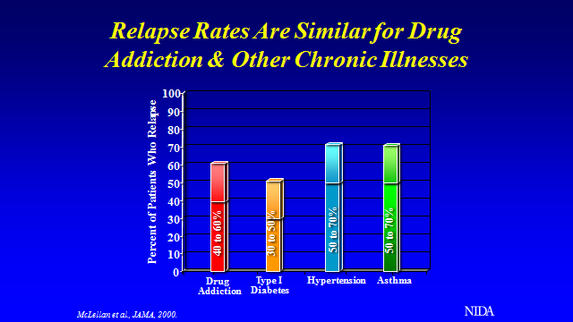

Like a person who is diabetic or has heart disease that doesn’t follow their diet and relapses with their disease or the asthma patient that sneaks cigarettes and smokes, patients with drug addiction often relapse as well. It’s a disease, and your loved one needs help.

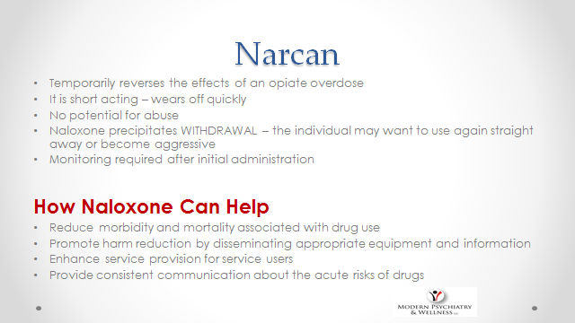

Overdose kits which contain Narcan are available by prescription at Fort Hamilton Outpatient Pharmacy. The cost is covered by most insurance companies.
Call 513-867-4490 for more information.
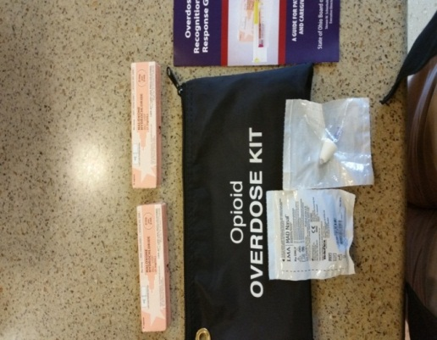
Community First Pharmacy now dispenses Narcan without a prescription. They can be reached at 513-726-3055.

